
Дисциплина:
Отчет по выполнению задания.

Выполнил:
Группа: 3ИСП11-44
Студент: Головенко Александр

Проверил преподаватель: Кондыбаева Алмагуль Бауржановна

Москва 2026 г.

Практическая работа №7
Задание 1 и выполнение кода
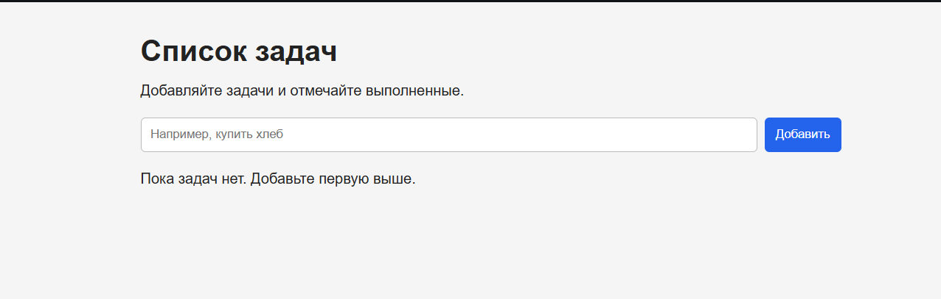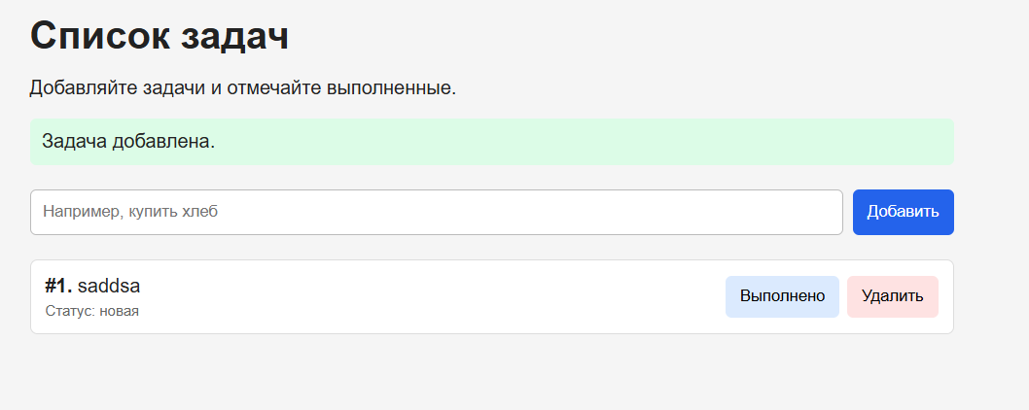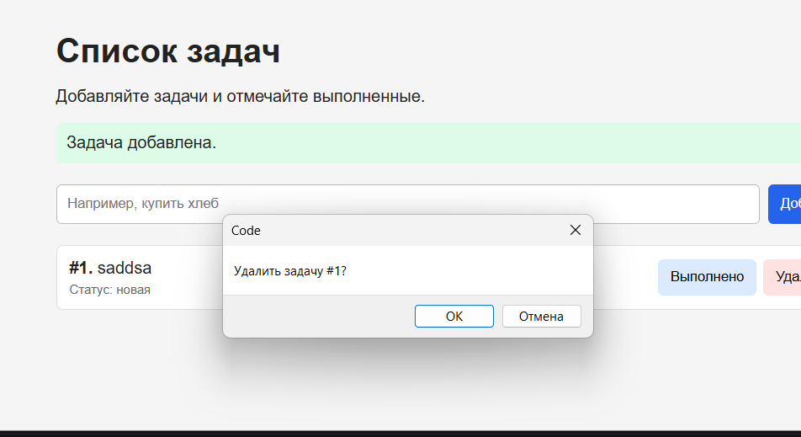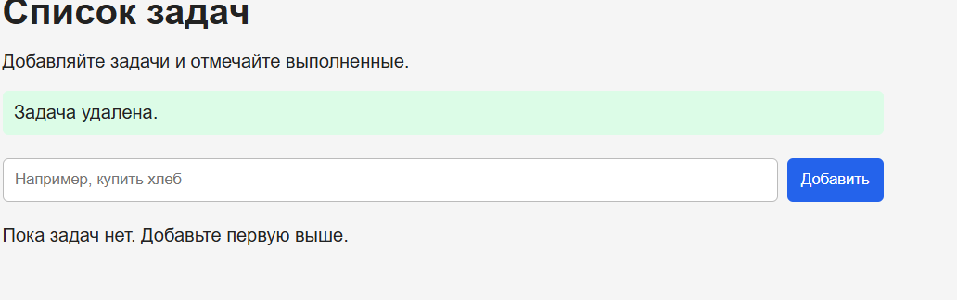
import sqlite3
from flask import Flask, render_template, request, redirect, url_for, flash

app = Flask(__name__)
app.secret_key = "pr7-simple-secret"
DB_PATH = "app.db"

def get_connection():
connection = sqlite3.connect(DB_PATH)
connection.row_factory = sqlite3.Row
return connection

def init_db():
"""Создаёт таблицу, если база запускается впервые."""
connection = get_connection()
try:
connection.execute("""
CREATE TABLE IF NOT EXISTS tasks (
id INTEGER PRIMARY KEY AUTOINCREMENT,
title TEXT NOT NULL,
status TEXT NOT NULL DEFAULT 'new'
)
""")
connection.commit()
finally:
connection.close()

def fetch_all_tasks():
connection = get_connection()
try:
return connection.execute(
"SELECT id, title, status FROM tasks ORDER BY id"
).fetchall()
except sqlite3.Error:
flash("Не удалось загрузить список задач.", "error")
return []
finally:
connection.close()

def insert_task(title):
connection = get_connection()
try:
connection.execute(
"INSERT INTO tasks (title) VALUES (?)",
(title,)
)
connection.commit()
return True
except sqlite3.Error:
connection.rollback()
return False
finally:
connection.close()

def toggle_task_status(task_id):
connection = get_connection()
try:
cursor = connection.execute("""
UPDATE tasks
SET status = CASE
WHEN status = 'done' THEN 'new'
ELSE 'done'
END
WHERE id = ?
""", (task_id,))
connection.commit()
return cursor.rowcount
except sqlite3.Error:
connection.rollback()
return 0
finally:
connection.close()

def delete_task_by_id(task_id):
connection = get_connection()
try:
cursor = connection.execute(
"DELETE FROM tasks WHERE id = ?",
(task_id,)
)
connection.commit()
return cursor.rowcount
except sqlite3.Error:
connection.rollback()
return 0
finally:
connection.close()

@app.route("/", methods=["GET", "POST"])
def index():
if request.method == "POST":
title = request.form.get("title", "").strip()

if not title:
flash("Введите название задачи.", "error")
elif insert_task(title):
flash("Задача добавлена.", "success")
return redirect(url_for("index"))
else:
flash("Не удалось сохранить задачу.", "error")

tasks = fetch_all_tasks()
return render_template("index.html", tasks=tasks)

@app.route("/toggle/<int:task_id>", methods=["POST"])
def toggle_task(task_id):
changed = toggle_task_status(task_id)
if changed == 0:
flash(f"Задача #{task_id} не найдена или не удалось изменить её.", "error")
else:
flash("Статус задачи изменён.", "success")
return redirect(url_for("index"))

@app.route("/delete/<int:task_id>", methods=["POST"])
def delete_task(task_id):
deleted = delete_task_by_id(task_id)
if deleted == 0:
flash(f"Задача #{task_id} не найдена или не удалось удалить её.", "error")
else:
flash("Задача удалена.", "success")
return redirect(url_for("index"))

if __name__ == "__main__":
init_db()
app.run(debug=True, port=5000)

СТИЛИ

<!doctype html>
<html lang="ru">
<head>
<meta charset="utf-8">
<meta name="viewport" content="width=device-width, initial-scale=1">
<title>Список задач</title>
<style>
body {
font-family: Arial, sans-serif;
max-width: 760px;
margin: 35px auto;
padding: 0 16px;
background: #f5f5f5;
color: #222;
}
h1 { margin-bottom: 8px; }
.add-form { display: flex; gap: 8px; margin: 20px 0; }
input[type="text"] {
flex: 1;
min-width: 0;
padding: 10px;
border: 1px solid #bbb;
border-radius: 5px;
}
button {
padding: 9px 12px;
border: 0;
border-radius: 5px;
cursor: pointer;
}
.add-button { background: #2463eb; color: white; }
.task-list { list-style: none; padding: 0; }
.task {
display: flex;
align-items: center;
justify-content: space-between;
gap: 12px;
padding: 12px;
margin-bottom: 8px;
background: white;
border: 1px solid #ddd;
border-radius: 6px;
}
.task-title { overflow-wrap: anywhere; }
.done { text-decoration: line-through; color: #777; }
.task-actions { display: flex; gap: 6px; flex-shrink: 0; }
.toggle-button { background: #dbeafe; }
.delete-button { background: #fee2e2; }
.status { font-size: 12px; color: #666; margin-top: 4px; }
.message { padding: 10px; border-radius: 5px; margin: 8px 0; }
.success { background: #dcfce7; }
.error { background: #fee2e2; }
@media (max-width: 520px) {
.task { align-items: flex-start; flex-direction: column; }
}
</style>
</head>
<body>
<h1>Список задач</h1>
<p>Добавляйте задачи и отмечайте выполненные.</p>

{% with messages = get_flashed_messages(with_categories=true) %}
{% for category, message in messages %}
<div class="message {{ category }}">{{ message }}</div>
{% endfor %}
{% endwith %}

<form class="add-form" method="post" action="{{ url_for('index') }}">
<input type="text" name="title" placeholder="Например, купить хлеб" maxlength="200">
<button class="add-button" type="submit">Добавить</button>
</form>

{% if tasks %}
<ul class="task-list">
{% for item in tasks %}
<li class="task">
<div class="task-title {% if item['status'] == 'done' %}done{% endif %}">
<strong>#{{ item['id'] }}.</strong> {{ item['title'] }}
<div class="status">
Статус: {% if item['status'] == 'done' %}выполнена{% else %}новая{% endif %}
</div>
</div>
<div class="task-actions">
<form method="post" action="{{ url_for('toggle_task', task_id=item['id']) }}">
<button class="toggle-button" type="submit">
{% if item['status'] == 'done' %}Вернуть{% else %}Выполнено{% endif %}
</button>
</form>
<form method="post"
action="{{ url_for('delete_task', task_id=item['id']) }}"
onsubmit="return confirm('Удалить задачу #{{ item['id'] }}?');">
<button class="delete-button" type="submit">Удалить</button>
</form>
</div>
</li>
{% endfor %}
</ul>
{% else %}
<p>Пока задач нет. Добавьте первую выше.</p>
{% endif %}
</body>
</html>

